PF LAB5
26K-3130
Bhavishka kumari
TASK1
#include <stdio.h>
int main(){
int age,marks;

prints("Enter student's age:");
scanf("%d",&age);
printf("Enter student's marks:");
scanf("%d",&marks);
if (age>=18){
if(marks>=50){
printf("Elligible for admission\n");
} else{
printf("not eligible: Marks are below 50\n");
}
} else {
printf("not eligible: age is below 18\n");
}
return 0;
}

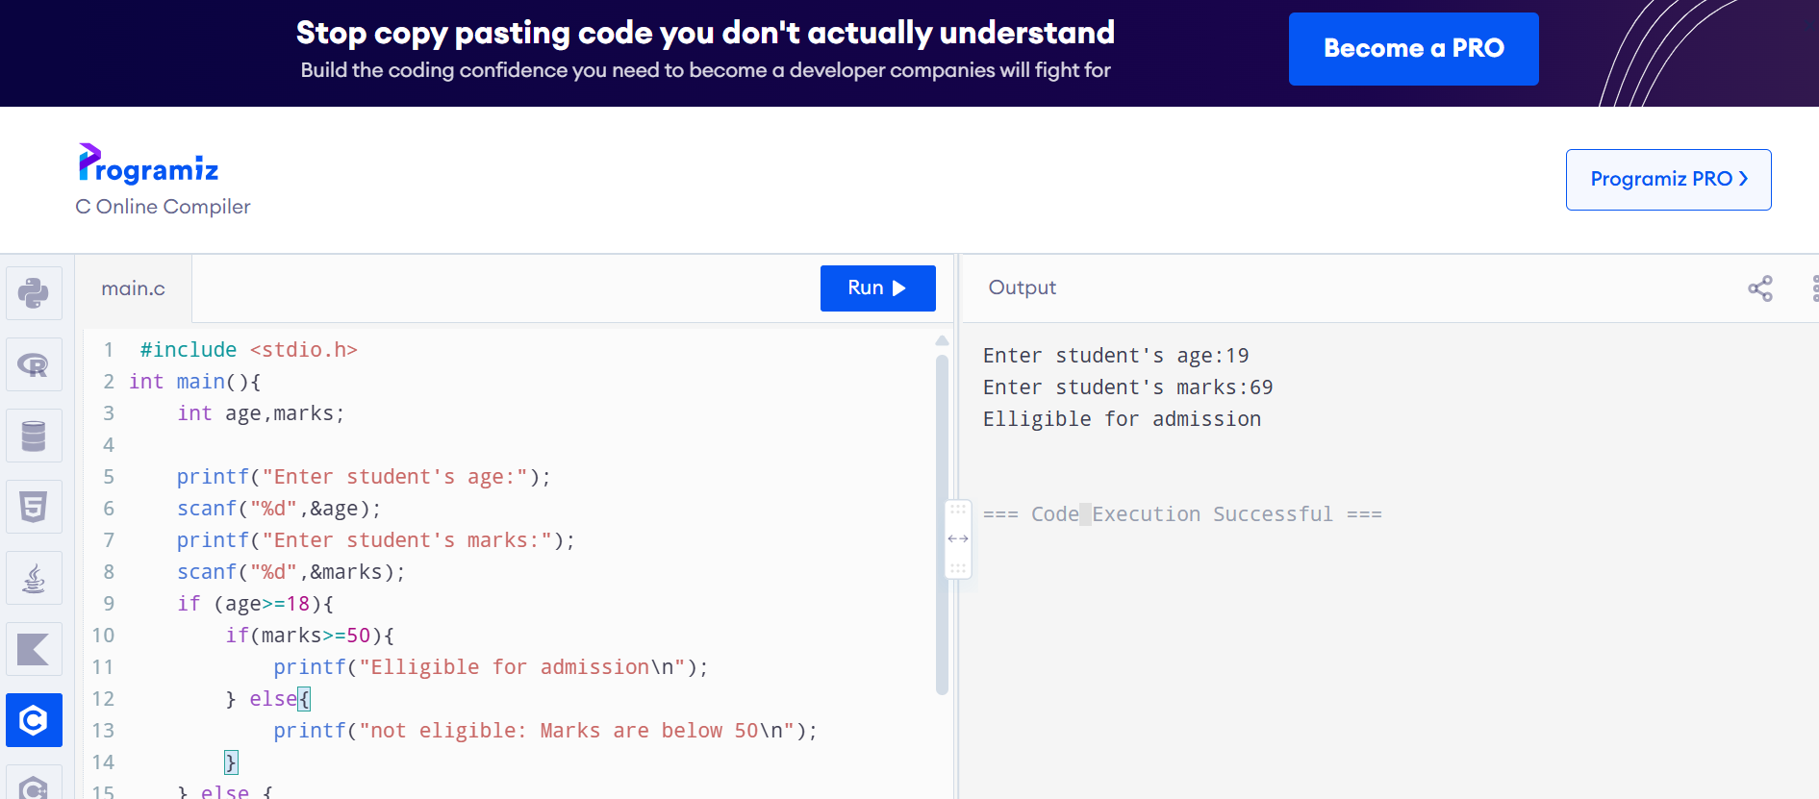

TASK2
#include <stdio.h>

int main() {
int hasCNIC, passedTest;

printf("Do you have a CNIC? (1 = Yes, 0 = No): ");
scanf("%d", &hasCNIC);

if (hasCNIC == 1) {
printf("Have you passed the driving test? (1 = Yes, 0 = No): ");
scanf("%d", &passedTest);

if (passedTest == 1) {
printf("License Can Be Issued\n");
} else {
printf("License Cannot Be Issued: You did not pass the driving test.\n");
}
} else {
printf("License Cannot Be Issued: CNIC is mandatory.\n");
}

return 0;
}
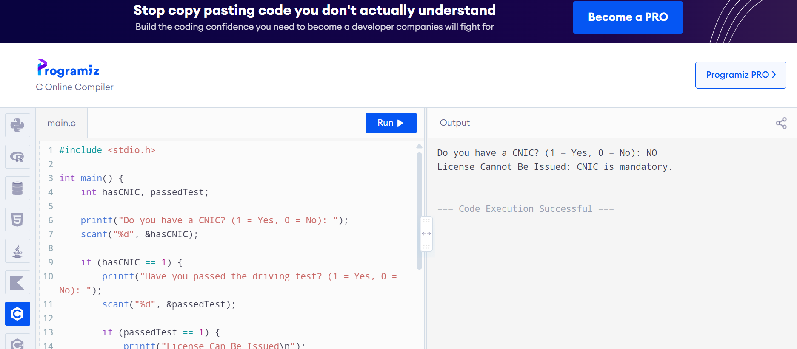
TASK4
#include <stdio.h>

int main() {
int marks;

printf("Enter marks: ");
scanf("%d", &marks);
(marks >= 50) ? printf("Pass\n") : printf("Fail\n");
return 0;
}
